# Introduction

Coronavirus disease (COVID-19) is an infectious disease caused by a newly discovered coronavirus, and it has affected major parts of the world. Nigeria, a West African country, has also been affected by the COVID-19 pandemic after recording its first case on 27th February 2020.

Nigeria is a country with 37 states - Federal Capital Territory included- and a fast-growing economic environment with about 200 million citizens. COVID-19 has affected several country activities as the country steadily progressed from its first case to shutting down major airports, state-wide lockdown, curfews, and reviving its economy.

In this analysis, I employed data science, data analytics and visualization skills to collect, explore and analyse data and generate insights on the effects of Covid-19 on the economy of Nigeria.

Covid-19 had strong negative effects on the economy of the world’s strongest countries. The effect of the pandemic on Nigeria, being a developing economy, would likely be worse. To reduce the impact of the pandemic on the economy of the country and help her heal, it is necessary to assess the extent of the pandemic.

This analysis attempts to discover the extent to which the pandemic has affected the country’s economy by analysing vulnerability data, economic data and datasets of the cases.

# Analysis and Discussion

## Data Overview

The Nigeria Centre for Diseases Control (NCDC) monitors the country’s COVID-19 situation and releases data on metrics across all the 37 states in the country. From NCDC COVID-19 [official website](https://covid19.ncdc.gov.ng/), I obtained the data by performing a web extraction or web scraping.

The Johns Hopkins University Centre for Systems Science and Engineering (JHU CSSE) publishes daily data on confirmed, death and recovered cases across different countries. I accessed the daily confirmed, recovered, death cases data for the world from their [repository](https://github.com/CSSEGISandData/COVID-19/blob/master/csse_covid_19_data/csse_covid_19_time_series/time_series_covid19_confirmed_global.csv).

I also made use of the Nigeria Vulnerability Index data. The vulnerability index was computed by considering several factors such as socioeconomic status, population density, housing type, transportation, epidemiological, health system etc, these factors are known as themes.

Finally, I made use of state budget data. States across the country reduced their initial budget due to the impact of COVID-19 on the economy.

## Methods

The following is a breakdown of methods used in the analysis:

1. **Web Scraping**: Data was scraped from the internet into the workspace as data frames.
2. **Data Loading**: External CSV datasets were loaded into the workspace as Pandas DataFrames.
3. **Drop Duplicates**: Pandas’ methods were used to remove rows from the imported data frames.
4. **Visualization**: Various graphs and tables were employed to show the relationship between measured variables in the various data frames.

## Analysis

1. I created a plot showing the top 10 states in the country in terms of Confirmed Covid cases by Laboratory test. The plot shows Lagos to be the highest, followed by the FCT then Kaduna.

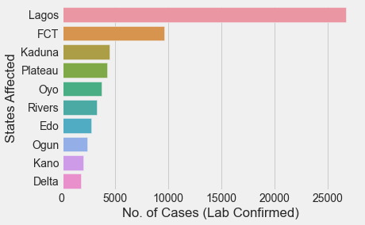

Figure 1: Plot of Top 10 States in Terms of Lab Confirmed Cases

1. I generated a plot showing the top 10 states in terms of Discharged Covid cases. The top three are the same as the previous chart except Plateau replacing Kaduna as the third.

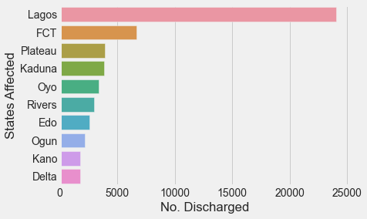

Figure 2: Figure 1: Plot of Top 10 States in Terms of Discharged Cases

1. I created a plot showing the top 10 states in terms of Covid death cases. Lagos retains its position on top of the chart.

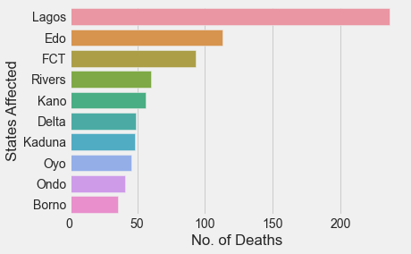

Figure 3: Plot Showing the Top 10 States in Terms of Death Cases

1. I generated plots showing the trend in total daily confirmed, recovered and death cases in Nigeria.

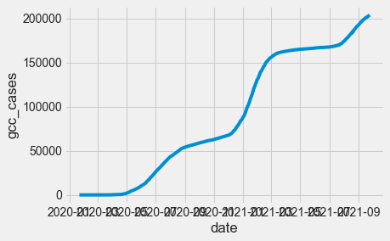

Figure 4:Trend of Total Daily Confirmed Cases

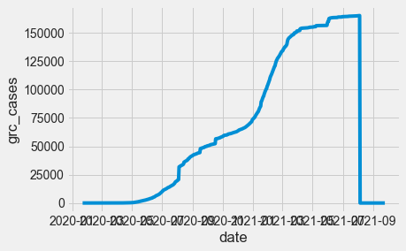

Figure 5: Trend of Total Daily Recovered Cases

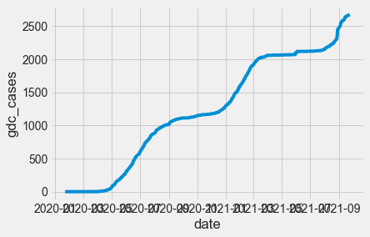

Figure 6: Trend of Total Daily Death Cases

1. I plotted the trend the infection rate of Covid-19 in Nigeria

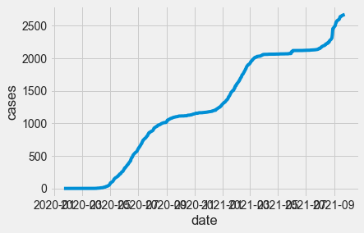

Figure 7: Trend of Total Daily Death Cases

1. I plotted a regression chart to determine the relationship between the Number of Cases (Lab Confirmed) and Population Density.

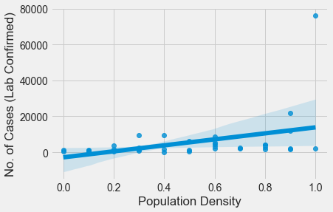

1. I plotted a regression chart to determine the relationship between the Number of Deaths and Age.

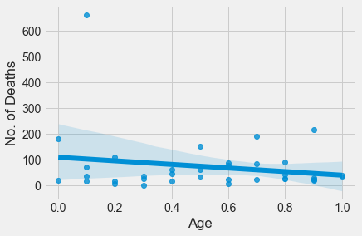

1. I plotted a chart to show the Real GDP of Nigeria in the first, second, thirdly and fourth quarters to prepare pre-pandemic, during-pandemic and post-pandemic. The chart shows that the Real GDP dropped in the second quarter but Nigeria was quick to recover in the third quarter.

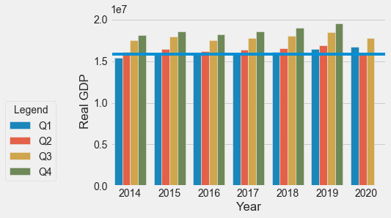

1. I plotted the daily infection rate of Covid-19 in Nigeria. The chart shows two apparent peak dates.

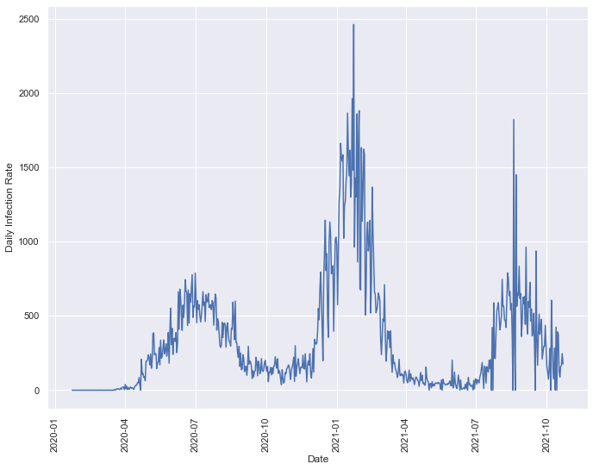

However, on inspection, the second peak date is 21st of January 2021 not the other apparent peak around August 2021.

|  |  |  |  |
| --- | --- | --- | --- |
| S/N | Date | Number of Cases | Infection Rate |
| 1 | 2021-01-23 | 120602 | 2464.0 |
| 2 | 2021-01-21 | 116655 | 1964.0 |

1. I plotted a chart of the ten most affected state budgets in Nigeria during the pandemic era. The ten most affected states (in decreasing order) are: Coss River, Lagos, Akwa Ibom, Rivers, Ogun, Delta, Imo, FCT, Kogi, Benue

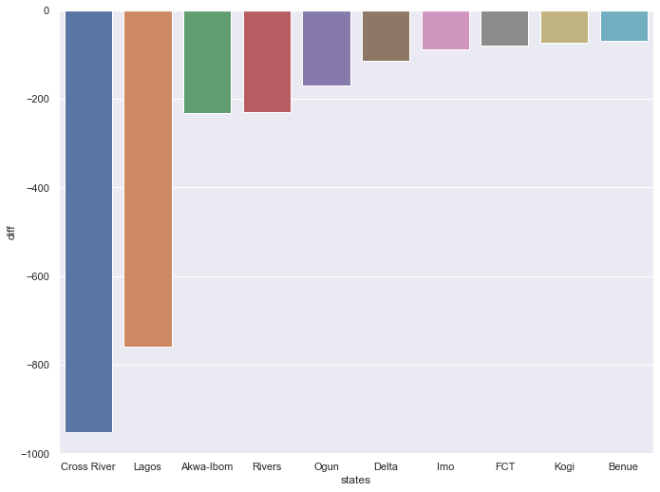

## Conclusion

In conclusion, this analysis used Python to import, clean, analyse and visualize data about Covid-19 in Nigeria.

The analysis showed that Lagos is the most affected but this could be due to its dense population. The pandemic also affected the economy of Lagos greatly as it’s budget is the second most affected in the country.

The analysis also showed that the Real GDP of Nigeria fell in the second quarter of 2020 which is the peak of the pandemic but rose in the third quarter.